**SMARTBRIDGE ASSIGNMENT -1**

**NAME: S POOJA**

**REGISTRATION NUMBER: 20MIS0037**

**COURSE: Modern Application Development (Java Spring Boot)**

Qn:

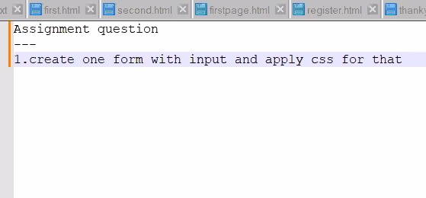

CODE:

<!DOCTYPE html>

<html>

<head>

<title>Login page</title>

<meta charset="utf-8" name="viewport" content="width=device-width, initial-scale=1">

<link rel="stylesheet" href="formStyle.css">

</head>

<body>

<div class="wrapper">

<center><h1>Contact us</h1></center>

<form method="post" class="form" name="form1" onsubmit="printValue(); return false;">

<div class="input">

<input type="text" placeholder="Name" required name="name">

<input type="text" placeholder="Email" required name="email">

<input type="text" placeholder="Phone Number" required>

<textarea placeholder="Enter Message"></textarea>

<center><input class="button" type="submit" name="submit" value="Send"></center>

</div>

</form>

</div>

<script type="text/javascript">

function printValue() {

var name = document.form1.name.value;

var email = document.form1.email.value;

alert('Welcome ' + name + ', your email is: ' + email);

}

</script>

</body>

</html>

OUTPUT:

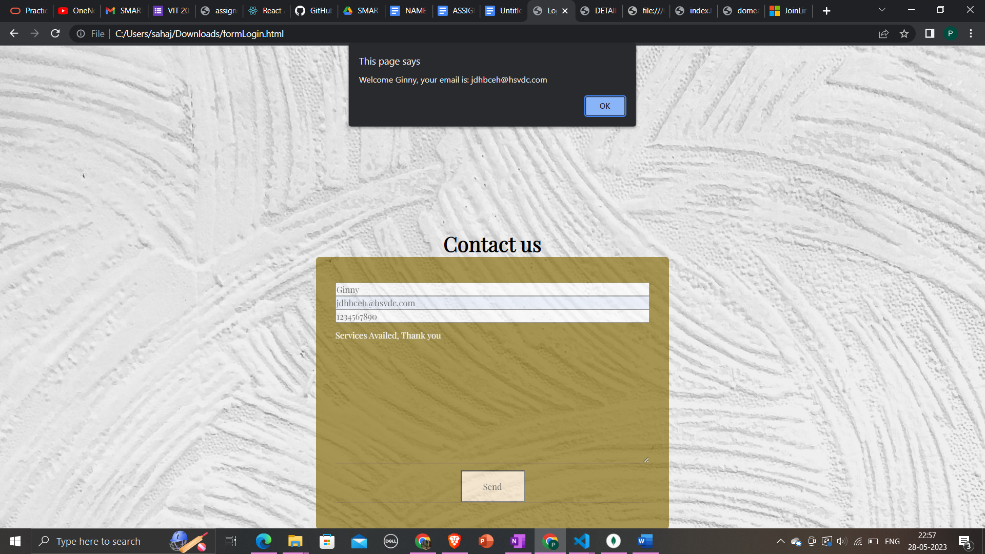

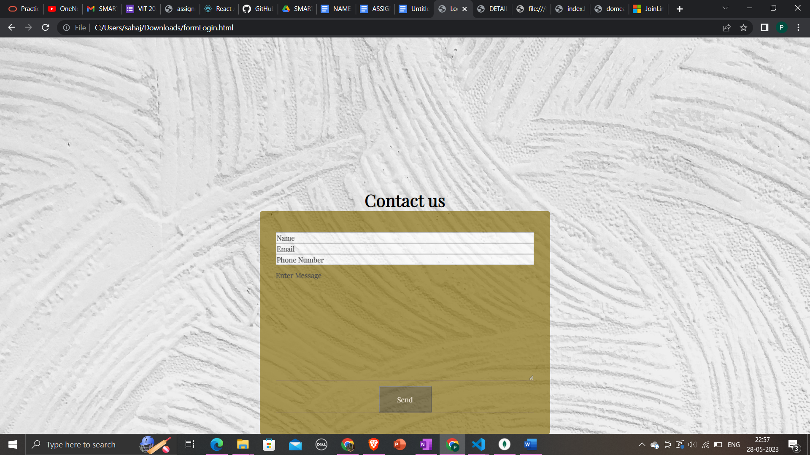

Hover:

